Plugin manual :

|  |  |
| --- | --- |
| http://localhost/MySite/graphiques/Settings.png | Wordpress Auto Back Up: |

This security plugin detect and backs up current WordPress database and WP-CONTENT folder with all its contents(themes, plugins, ...) and send them to Email inbox that's registered in admin interface, these done automatically in function to frequency time that is adjusted , without need to back up them manually every time, these backed up automatically when visitor access to your site web pages or when you get access to your Wordpress administrator interface, so this plugin useful in case you have loosed or modified your databases either deleted accidentally or hacked, so you have a chance 100% to recover them safely.

#### Browsers compatibility

|  |  |
| --- | --- |
| http://localhost/MySite/graphiques/Check.png | Mozilla FireFox. |
| http://localhost/MySite/graphiques/Check.png | Google Chrome. |
| http://localhost/MySite/graphiques/Check.png | Internet Explorer. |
| http://localhost/MySite/graphiques/Check.png | Opera Mini . |
| http://localhost/MySite/graphiques/Check.png | Safari . |

#### Wordpress version compatibility

* Wordpress v3.1
* Wordpress v3.2
* Wordpress v3.3
* Wordpress v3.4
* Wordpress v3.5
* Wordpress v3.6
* Wordpress v3.7
* Wordpress v3.8
* Wordpress v3.9
* Wordpress v4.0
* Wordpress v4.1
* Wordpress v4.2
* Wordpress v4.2.3

#### Plugin advantages:

|  |  |
| --- | --- |
| http://localhost/MySite/graphiques/Check.png | Automatic back up to Email inbox. |
| http://localhost/MySite/graphiques/Check.png | Manual back up to Email inbox. |
| http://localhost/MySite/graphiques/Check.png | Manual databases restore . |
| http://localhost/MySite/graphiques/Check.png | Setting adjusting (frequency backup time, Email address change). |
| http://localhost/MySite/graphiques/Check.png | Administrator interface manipulation. |
| http://localhost/MySite/graphiques/Check.png | List all current Wordpress Database Tables. |

#### How to install plugins?

#### 1-Copy plugin files in WordPress directory:

"wordpress\wp-content\plugins"

#### 2-Login to admin interface:

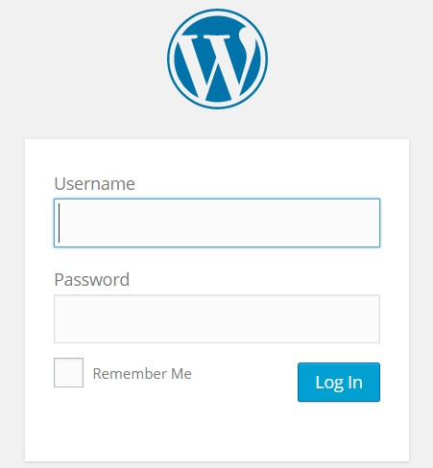  
  
  
Admin interface after succes login  
  
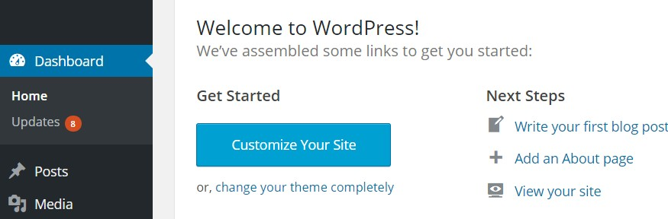

#### 3-Click on 'plugins' menu:

Intalled plugins listed, click on 'Activate' on 'DataBases Auto Back Up'  
  
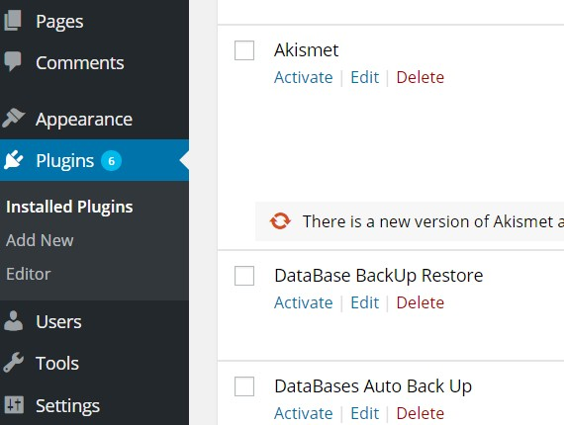

#### 4-Changes made when install plugin:

***A-New menu added on admin interface***  
  
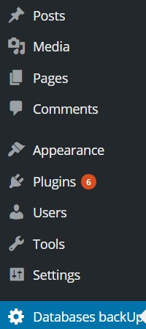  
  
***B-New table 'wp_database_autobackup' added on 'wordpress' database***

#### 5-Plugins parts

***Plugin defition***  
  
This give a definition of plugin  
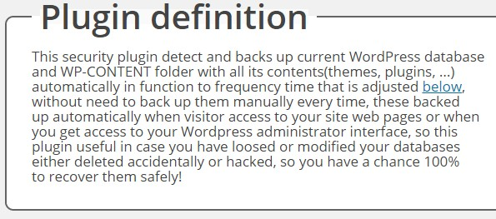  
  
***WordPress Database & tables list***  
  
List WordPress database with its tables  
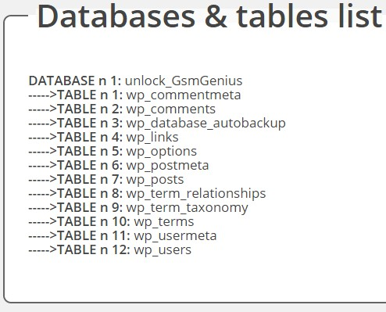  
  
***Update DataBases***  
  
This section allow to update databases from files that are backed up automatically  
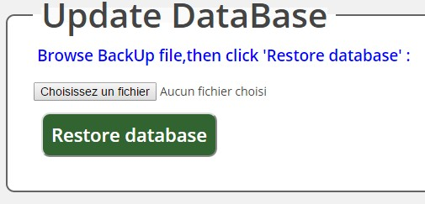  
  
***Wordpress Back up state***  
  
This allow to update databases from files that are backed up, and make manual back up  
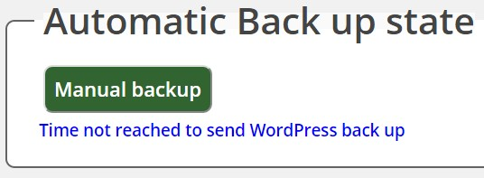  
  
***Settings***  
  
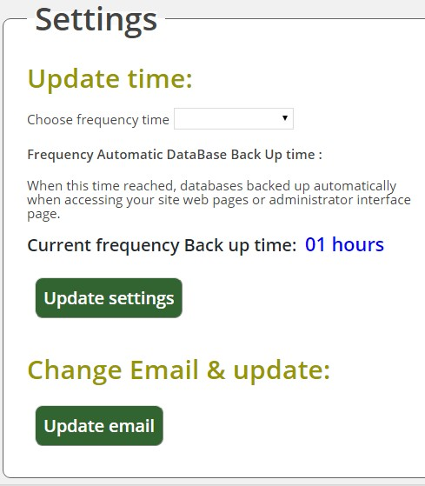  
**Update time:** Adjust Wordpress back up time , and gives current time adjusted  
**Update Email:** Change email address to send wordpress backs up

#### -About author

Professional web and plugins programmer & designer with PHP, HTML, CSS .  
**Email:**[**GsmGenius2015@gmail.com**](mailto:GsmGenius2015@gmail.com)